**A**

**PROJECT REPORT**

**ON**

**“Process parameter optimization of Inconel 718 material by using Taguchi optimization method.”**

**Submitted to**

**SHIVAJI UNIVERSITY, KOLHAPUR**

**IN PARTIAL FULFILLMENT OF THE REQUIREMENT FOR THE AWARD OF BACHELOR’S DEGREE IN MECHANICAL ENGINEERING**

***Submitted by***

**NADIM AYUBKHAN SANADI . [19UME085]**

**SHRAVAN DEEPAK SATPUTE.**  **[19UME086]**

**PRATHAMESH JAGGANAT SAWANT. [19UME089]**

**RUPESH SADANAND SHENDE. [19UME094]**

***Under guidance of***

**(PROF.) K.****K. POWAR .**

**DEPARTMENT OF MECHANICAL ENGINEERING**

**(AN AUTONOMOUS INSTITUTE WITH NAAC GRADE A+ ACCREDIATION)**

**(2022 – 23)**

**D.K.T.E SOCIETY’S**

**TEXTILE AND ENGINEERING INSTITUTE, ICHALKARANJI**

**(AN AUTONOMOUS INSTITUTE WITH NAAC GRADE A+ ACCREDIATION)**

**DEPARTMENT OF MECHANICAL ENGINEERING**

**CERTIFICATE**

This is to certify that,

**NADIM AYUBKHAN SANADI . [19UME085]**

**SHRAVAN DEEPAK SATPUTE.**  **[19UME086]**

**PRATHAMESH JAGGANAT SAWANT. [19UME089]**

**RUPESH SADANAND SHENDE. [19UME094]**

Have presented and submitted the project entitled “**Process parameter optimization of Inconel 718 material by using Taguchi optimization method.”** the partial fulfillment for the award of the degree of bachelor’s in mechanical engineering at Shivaji University, Kolhapur.

This is the record of their work carried out during the academic year 2022-23.

**Place:**

**Date:**

**PROF. (Dr.) V. P. GAIKWAD PROF. (Dr.) V. R. Naik**

**(Project Guide) (Head of Department)**

**Prof. (Dr.) L. S. Admuthe**

**(External Examiner) (I/C Director)**

**ACKNOWLEDGEMENT**

Words are inadequate to express the overwhelming sense of gratitude and humble regards to my guide supervisor **Prof. K.K.POWAR** Assistant Professor, Department of Mechanical Engineering for his constant motivation, support, expert guidance, constant supervision and constructive suggestion for the submission of my progress report of project work “**Process parameter optimization of Inconel 718 material by using Taguchi optimization method**”. I express my gratitude to **Prof. (Dr.) V.R. Naik,** Professor and Head of the Department, Mechanical Engineering for his invaluable suggestions and constant encouragement all through the work. I also thank all the teaching and non-teaching staff for their nice cooperation to the students. This report would have been impossible if not for the perpetual moral support from my family members, and my friends. I would like to thank them all.

STUDENTS NAME PRN NO

**NADIM AYUBKHAN SANADI . [19UME085]**

**SHRAVAN DEEPAK SATPUTE.**  **[19UME086]**

**PRATHAMESH JAGGANAT SAWANT. [19UME089]**

**RUPESH SADANAND SHENDE. [19UME094]**





**ABSTRACT**

Inconel 718, a high strength, thermal resistant 50% Nickel-based alloy, is mainly used in the aircraft industries and tractor hub pin. Due to the extreme toughness and work hardening characteristic of the alloy, the problem of machining Incone1 718 is one of ever-increasing magnitude. This project discusses the effect of cutting conditions on the machinability of Incone1 718. This project focused on optimizing the cutting conditions for the average surface roughness (Ra) obtained in machining of high-alloy white cast iron (Ni-Hard) at 50 HRC. Machining experiments were performed at the CNC lathe using carbide and cubic boron nitride (CBN) cutting tools on Ni-Hard materials. Cutting speed, feed rate and depth of cut were chosen as the cutting parameters. Taguchi L9 orthogonal array was used to design of experiment. Optimal cutting conditions was determined using the signal-to-noise (S/N) ratio which was calculated for Ra according to the ‘‘the-smaller-the-better’’ approach. The effects of the cutting parameters and tool materials on surface roughness were evaluated by the analysis of variance. The statistical analysis indicated that the parameters that have the biggest effect on Ra for Ni-Hard materials with 50 HRC are the cutting speed and feed rate, respectively. Additionally, the optimum cutting conditions for the materials with 50 HRC was found at three different levels.

**INDEX**

Sr No Title Page No

1  **Introduction**  1

1.1 Motivation of project

* 1. Background

2 **Litrature Review**

2.1 Machinability of Inconel 718 Material

2.2 Taguchi Technique in Machining Optimization

**2**.3 Overview of Surface Roughness And Tool Wear

3 **Problem Definitions**

3.1 Objectives

3.2 Methodology

4 **Experimental Setup**

4.1 CNC Machine

4.2 Inconel 718 Round Bar

4.3 Tool insert

4.4 Optical profile projector

4.5 Tally Surf

4.6 Wire EDM

5 **Theory**

5.1 Design of Experiments

5.2 Taguchi Approach

5.3 A steps in Taguchi experimental Design

5.4 Deciding the number of levels.

5.5 Process selection

5.6 Selection of an orthogonal Array

5.7 Assigning the independent variables in column.

5.8 counting the Experimentation.

5.9 Experimental Work

5.10 Analyzing the data.

5.11 Analysis of Variance.

5.12 Signal to noise ratio.

6 **Results**

6.1Effect of Process Parameter on Surface Roughness.

6.2 Effect of Process Parameter on Tool Wear.

7 **Graphical representation for the tool wear and surface roughness.**

7.1 Surface Roughness

7.2 Tool Wear

8 **Conclusion**

8.1 Optimum value of surface roughness obtained in experimentation.

8.2 Optimum value of tool wear obtained in experimentation

9  **Cost Estimation**

10  **References**

**List of figure**

**Sr.No Title Page No**

4.1 CNC Machine

4.2 Inconel 718 Round Bar

4.3 Tool insert

4.4 Optical profile projector

4.5 Tally Surf

4.6 Wire EDM

**List Of Table**

Sr.No Title Page No

4.2.1 For Material Properties

5.6.1 Selecting critical parameters and levels

5.7.1 Experimental layout

5.7.2 DOE with L9 Array

6.1.1 For Surface Roughness

6.1.2 for Tool wear

8.1.1 For Optimum surface value

8.2.1 For Optimum Tool Wear

**CHAPTER 1**

**INTRODUCTION**

The cutting or processing of metals is considered one of the most important and versatile processes to give the final shape to the preformed blocks and to the various manufactured articles obtained by casting or forging. Most of the components produced all over the world necessarily require processing to turn them into finished products. This is the only process where the final product shape is obtained by removing the excess material in the form of chips from the work material provided with the help of a cutting tool. The basic processes of chip formation include turning, profiling, milling, drilling, etc. A large amount of heat is generated in the machining processes and in other processes where material deformation occurs. Heat is a parameter that strongly influences the performance of the instrument during these processes. The heat generated in the tool / work interface is of great importance in relation to tool performance and it is particularly important to limit the metal removal rates during cutting of iron, steel and other metals and high melting point alloys. In most publications, heat generation in this region is treated on the basis of the classical theory of friction; here the subject is reconsidered in the light of evidence that seizure is a normal condition in the instrument / work interface. First of all, it is necessary to analyze in more detail the deformation model in the accumulated edge or in the flow area, which are the main sources of heat that increase the temperature of the instrument.

There is study focused on the effect of tool geometry parameters on the surface roughness during turning. The response surface methodology and a prediction model were developed related to the Ra using experimental data.

The purpose of this study is to obtain optimal cutting conditions (cutting tool material, cutting speed, feed rate and depth of cut) for minimizing the Ra when turning high-alloy white cast iron (Ni-Hard) material also with 50 HRC. Taguchi's design and analysis of experiment process has been used to achieve this purpose.

L9 orthogonal array was used in the design of experiment. Furthermore, analysis of variance is used to determine the statistical significance of the cutting parameters. Finally, confirmation tests were carried out using the optimal cutting conditions which were determined by Taguchi optimization method.

**1.1 Motivation Of Project**

Studies reported that, while machining titanium alloys, carbide cutting tools have proved their excellence in almost all processes, except of the tool wear. Many cutting tool materials used for machining Nikel alloys usually have short tool life and most react with the titanium work materials. This disadvantage is due to the generation of elevated temperatures closer to the cutting edge of the tool. Most of the problems associated with conventional machining of alloys is with high consumption of cutting tool materials due to excessive tool wear as a result of high-temperature generation at the cutting interfaces. The aim of this work is to investigate the effect of various tool coatings in machining of Nikel alloy Inconel 718 .The effect of various tool coatings with cutting parameters on tool wear and surface roughness will be evaluated.

* 1. **Background**

Perfect Cut Solution”, indulged in manufacturing a wide range of Bandsaw Machine, Twin Spindle Tapping SPM, etc. We have attained a renowned position in this highly competitive industry. Inconel 718 Metal turning process is the major process in industry for the design development.

Inconel-718 is characterized by high yield strength, high-strength, and corrosion resistance, which has been used in a wide range of applications at elevated temperature ∼700 °C, such as gas turbines, liquid fueled rockets, aircraft, nuclear reactors, pumps and mold. INCONEL alloy 718 is one of the many nickel-based superalloys supplied by Corrothers. Its exceptional properties and technical specifications mean that it’s used for lots of highly technical and essential industrial applications.

It is mostly chosen by design engineers thanks to its high strength in extreme temperature conditions at both ends of the spectrum. It can be used in environments from cryogenic all the way up to 1300°F/704°C. Throughout this entire range it exhibits exceptionally high yield, tensile and creep-rupture properties. It also shows excellent tensile and impact strength.

**CHAPTER 2**

**LITERATUR REVIEW**

The literature review indicates that the machinability studies of Nikel based material, Taguchi‘s technique in machining optimization, response surface methodology in machining optimization, surface roughness and Tool wear measurement are extensively discussed.

**2.1 Machinability of Inconel 718 Material**

Nickel-based superalloys are widely employed in the aerospace industry, in particular in the hot sections of gas turbine engines, due to their high-temperature strength and high corrosion resistance. They are known to be among the most difficult-to-cut materials.

Inconel 718 is a high-strength, thermal-resistant (HSTR) Nickel-based alloy [1] that plays an increasingly important part in the development and manufacture of jet aeroengines. It is also noted for its excellent corrosion resistance. Due to its extremely tough nature, the difficulty of machining Inconel 718 resolves itself into two basic problems: (1) the inability of the tool material to give long tool lives due to the work hardening and attrition properties of the alloy and (2) the metallurgical damage to the workpiece due to the very high cutting forces which also gives rise to work hardening, surface tearing and distortion in finally machined components due to induced stresses

Machinability studies [2-6] of this material have been carried out by different researchers. In a study using C2 carbide grade tools, it was found that [2] the dominant causes of tool failure were localized groove wear on the side flank and chipping on the side cutting edge. It was further observed that the effect of depth of cut on tool wear was not so significant in comparison to the effects of speed and feed. However, it was found [3] that surface finish deteriorated with increasing speed for Incone1 718. The effect of tool nose radius and feed was not significant on surface roughness. A study [4] on the performance of machinability oflncone1 718 showed that the Elsevier Science SA PII 80924-0136(96)02624-6 tool life of the silicon nitride based material was mainly dependent on flank wear, whereas for the silicon carbide whisker-reinforced alumina, the tool life criterion was depth of cut notch wear. It has been found [5] that at lower speeds, ceramic tools were prone to depth of cut (DOC) notch wear with minimal damage to the tool nose and at higher speeds, there was a reduction in depth of cut notching and an increase in nose and flank wear.

A recent study [6] was carried out using coated cemented carbide inserts of four different grades and a ceramic insert of grade NS13OC. It was found that the coated cemented carbide inserts performed best at the lowest speed and feed rate. The ceramic insert was unsuitable for machining Incone1 718 as the tool life was less than one and a half minutes for all the cutting conditions tested. The major failure mode of the inserts were DOC notch wear. Both the carbide and the ceramic inserts exhibited excellent resistance to crater wear.

**2.2 Taguchi Technique in Machining Optimization**

Yang and Trang (1998) used the Taguchi technique to determine the optimal cutting parameters for the turning process. The signal-to-noise ratio and the analysis of the variance are used to study the cutting parameters for S45C steel using tungsten carbide tools. The main parameters influencing the cutting parameters are determined together with the optimal machining parameters for turning operations. Nalbant et al (2007) used the Taguchi method to determine the optimal cutting parameters for surface roughness in turning operations. The orthogonal matrix, the signal-to-noise ratio, the analysis of the variance is used to investigate the cutting parameter in the turning operations of AISI 1030 steel with TiN coated tools. The cutting parameters used during these surveys are: insertion radius, feed speed and depth of cut and the measured response to these cutting parameters is the roughness of the surface. The Taguchi technique proved to be the best method to study the optimal cutting parameters during turning operations.

Hascalik and Caydas (2007) studied the surface roughness and useful life of the instrument to transform the titanium alloy using the Taguchi technique. The Taguchi technique is used to demonstrate the design of the Taguchi parameter, using surface roughness and tool life for a particular combination of cutting parameters. The cutting parameters used are the cutting speed, the feed rate and the cutting depth with respect to the responses, the roughness of the surface and the useful life of the tool. It is observed that the feed speed and the cutting speed are the dominant parameters which respectively influence the surface roughness and the useful life of the instrument. The roughness of the surface is strongly influenced by the cutting speed and the useful life of the tool is strongly influenced by the axial cutting depth.

Singh et al (2004) demonstrated the Taguchi parameter design to obtain optimal cutting parameters while turning En24 steel using coated carbide inserts. The cutting parameters considered in this work are cutting speed, feed and depth of cut. The responses measured for the investigations are flank wear and crater wear. En24 steel is a difficult to cut material and the results indicated that the selected cutting parameter have a great influence on turning En24 steel. Suhail et al (2010) reported that surface roughness is an integral property of machining operations. The optimum surface quality will be obtained only by the proper selection of cutting parameters during turning operations. The researcher has employed the responses in this work as cutting temperature and surface roughness. The performance characteristics study of the turning operations are studied using orthogonal array, signal to noise ratio and analysis of variance technique. It is proved that the surface roughness can be taken as a quality indicator to control the cutting operation and to obtain the best optimum results. Best optimum machining parameters selection will result in increased machine utilization and decreased production cost in an automated manufacturing environment.

Somasekahara and Swamy (2012) investigated the Taguchi parameter design to select the optimal cutting parameters in selection of optimum value of surface roughness while machining Aluminum alloy with uncoated carbide inserts. The several other optimization techniques such as genetic algorithm, response surface methodology are also considered for the determination of optimal cutting parameters. They proved that Taguchi techniques bring in the best result in selection of cutting parameters and also suggested the dominant factor influencing the surface roughness while turning operation.

Patel and Deshpande (2014) focused on achieving high quality in terms of product accuracy and high surface finish. The production of products should affect environmental factors linked to a minor impact. To reduce the price of the product, it is unavoidable to check the cutting parameters involved in the machining, such as cutting speed, feed speed, depth of cut, tool geometry, considerations on materials, etc. Optimizing these control parameters will influence responses such as material removal speed, tool life, tool wear, energy consumption, etc. The Taguchi technique was used to relate the influence of responses to cutting parameters and proved to be useful at all levels of the manufacturing sectors.

Sahoo and Sahoo (2011) implemented Taguchi parameter design and response surface methodology to develop the mathematical model and parametric optimization of D2 steel using TiN coated carbide inserts. The influencing parameters on surface roughness are evaluated and also the optimal condition of cutting parameters computed. It is concluded that the influencing parameter in minimization of surface roughness is feed rate followed by depth of cut. The experimental results have proved that the surface roughness variation is at the mean level, at the low and high cutting speeds and depth of cut have a very little influence on the cutting parameters in optimization of surface roughness.

**2.3 Overview of Surface Roughness And Tool Wear .**

In recent past, hard turning of steel parts with hardness in the range of 45–68 HRC became an emerging technology, which has been recognized as a profitable alternative to cylindrical grinding and assured various benefits over grinding practice with respect to reduced setup time, lower production cost, reduced power consumption, improved surface integrity due to higher MRR, greater process flexibility and reduction or elimination of environmentally harmful cooling media (König et al., 1993; Tosheff et al., 2000; Grzesik, 2008; Sieben et al., 2010). In hard turning, surface finish of machined parts has become most important technical requirement as it improves fatigue strength, tribological properties, corrosion resistance and creep life (Singh and Rao, 2007; Shihab et al., 2014). It is therefore clear that control of the machined surface is essential (Sharma et al., 2008) and it can be achieved by the evaluation of cutting force as it correlates strongly with cutting performance (surface accuracy, tool wear and breakage, power consumption, cutting temperature and forced vibration, etc.).

Additionally, for successful implementation of hard turning, understanding of process parameter optimization (modelling of in-process parameter relationships and determination of optimal cutting condition) is needed to appreciate cutting efficiency and develop high quality products at minimum processing cost. Various experimental studies have been performed to assess the parametric effects, and to model and optimize the cutting conditions for surface roughness and cutting forces in hard turning.

Ohtani and Yokogawa [3] state that the main wear mechanism of CBN and ceramic tools in the machining of cold work tool SKD11 (hardness range HRC 18–60) is abrasion by hard alloy carbide particles contained in the workpiece structure. The lifespan of carbide tools decreases as workpiece hardness increases, while the ceramic and CBN tool-life shows the opposite results. Matsumoto et al. [4] performed cutting tests on AISI 4340 steels with hardness range HRC 29–57 using ceramic (Al2O3–TiC) tool inserts. They observed when steels in the hardness range HRC 30–50 were cut, continuous chips were observed, and an increase in hardness caused a decrease in cutting force. This phenomenon was also observed by Chao and Trigger [5]. When the hardness exceeded HRC 50, chip segmentation appeared and there was a sudden increase in cutting forces. Similar results were obtained by Eda et al. [6] while cutting maraging steels of various hardness.

Musta fizurahman et al (2006), Ramesh et al (2008), Ezugwu et al (1997), Ozel et al (2010) experimented several experiments to determine the importance of surface roughness and wear rate in a machining operation. It is discovered that high wear rate may lead to an uneconomical machining and eventually poor surface finish will be obtained on the surface of the work piece. The wear rate of titanium machining is controlled using CBN as tooling material. Nouari and Ginting (2006) investigated the performance of alloyed cutting tool while machining pure titanium material and studied the wear mechanism of the tool.

**CHAPTER 3**

**Problem Definitions**

High-alloy cast irons are an important group of materials which has alloy content above 4%. Cast irons with alloy content of below 4% are called low-alloy cast iron with 350–550 Hardness Brinell (HB). Specifications of high-alloy cast iron (450–850 HB) such as wear, heat and corrosion resistance are significantly higher than the other non-alloyed or low-alloy cast iron. The main alloying elements used in high-alloy cast irons are nickel, chromium, molybdenum, copper and vanadium [1]. These materials are called Ni-Hard, Cr-Hard, etc., according to their alloy content. Ni-Hard is the name of high-alloy white cast iron which has a very high wear resistance with 58–65 Hardness Rockwell C (HRC) [2]. Ni-Hard materials are used in areas such as ore breakers, roller mills, agricultural machines, pistons, conveyors, pumps, gears and mining industry due to their high wear resistance and hardness [3,4]. However, these materials are generally used as they are cast because of the low machinability of these materials having high wear resistance. On the other hand, the traditional method of machining the hardened materials includes rough turning, heat treatment, and then grinding process. The various advantages of hard turning are the higher productivity, reduced set up times, surface finish closer to grinding and ability to machine the complex parts [5]. Various work materials which can be machined by the hard turning process include high speed steels, die steels, bearing steels, alloy steels, case hardened steels, white cast iron and alloy cast iron. Since the hard turning process contains many parameters, it is complex and difficult to select the proper cutting conditions and tool geometry for achieving the required surface quality [6]. However, it is necessary to determine optimal cutting parameters in order to attain minimal costs or minimal cost/production time. Thus, the application of hard turning technology can be improved by utilizing advanced optimization algorithms such as particle swarm optimization. As a result, manufacturers can make better decisions when dealing with multiple conflicting objectives [7,8].

* 1. **Objectives**

1. Aim: Investigation on the turning of Inconel 718 using Carbide insert tools. The Taguchi optimization method as well as an L18 orthogonal array is used for analysis (S/N) ratio and analysis of variance (ANOVA) are employed to examine the performance characteristics of the turning operations. The three parameters are used for analysis of tool wear and surface roughness is cutting tool, depth of cut, cutting speed, feed rate.
2. Average surface roughness (Ra) occurred during machining of the Inconel 718 materials was measured after the experiments performed according to the L18 orthogonal array. The experimental results and S/N ratios calculated according to Taguchi's "the- smaller-the-better" quality characteristic.
3. Objective:
4. Collection of research papers for the project.
5. To investigate the effect of tool wear.
6. To calculate the surface roughness.

**3.2 METHODOLOGY**

* 1. The methodology followed for this dissertation work is as follows:

1. Review the literature to study existing work done in the area of machining of Nike alloy Inconel 718
2. Selection of cutting parameters – cutting speed (v), depth of cut (d) and feed rate (f)
3. Formation of design of experiment (L9 OA) using Taguchi Methodology.
4. Performing experimentation by varying cutting parameters (v, d, f).
5. Measurement surface roughness with surface roughness tester.
6. Measurement Tool Wear using optical profile projector.
7. Interpretation of results.
8. Conclusion and Documentation

**CHAPTER 4**

**EXPERIMENTAL SETUP**

|  |  |
| --- | --- |
| **SR NO** | **COMPONENT** |
| **1** | **CNC MACHINE** |
| **2** | **INCONEL 718 ROUND BAR** |
| **3** | **CARBIDE INSERT** |
| **4** | **PROFILE PROJECTOR** |
| **5** | **TALLY SURF** |
| **6** | **WIRE EDM MACHINE** |

**4.1 CNC MACHINE :-**

All turning exercise, required for this experiment, were carried out on the DKTE textile and engineering institute workshop .CNC machine is used to turning operation

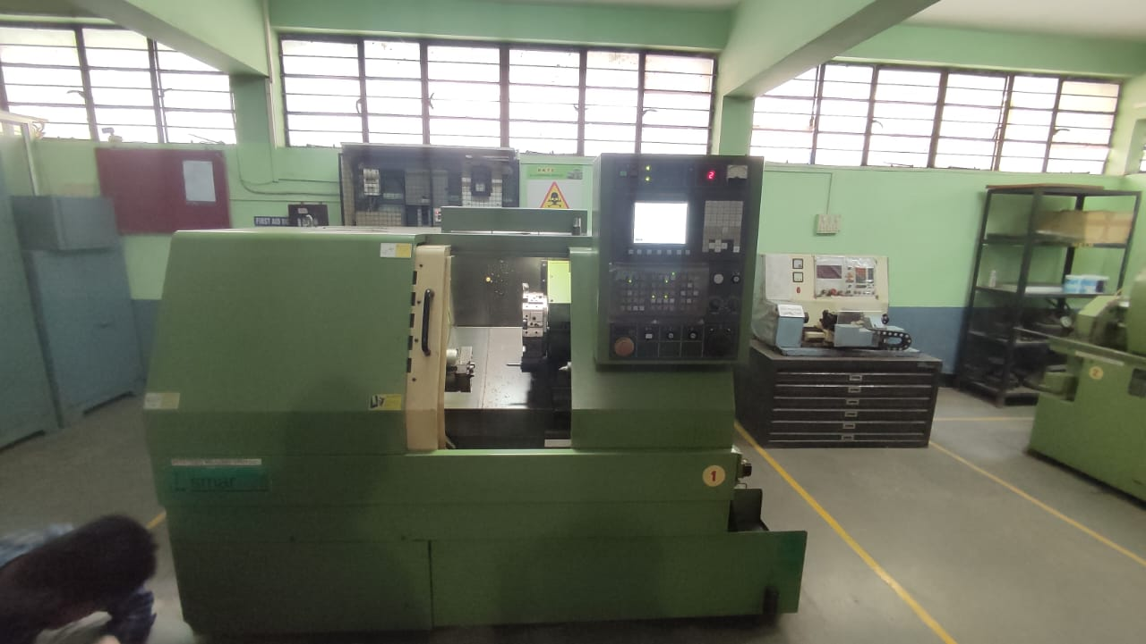

Specification of CNC machine

|  |  |
| --- | --- |
| **Model Name/Number** | Smart Turn |
| **Controller** | Fanuc |
| **Max Turning Diameter** | 200 mm |
| **Automatic Mode** | Automatic |
| **Voltage** | 415 |
| **Brand/Make** | 2017 |
| **Brand** | LMW |

**4.2 Selection of Work Specimen**

Based on the literature survey work specimen is selected for the experimentation is Inconel 718 annealed round bar in the form of round bar of 30 mm diameter and 60 mm length each for ease of experimentation. Figure 3.1 shows Inconel 718 round bar used for project work.

 

Image : Test specimen specification

**Material Properties**

Chemical Composition of Inconel 718

|  |  |  |  |
| --- | --- | --- | --- |
| SR NO | Element | Actual Value | Remark |
| 1 | Ni % | 50.6 | 50.00-55.00 |
| 2 | Cr % | 18.4 | 17.00-21.00 |
| 3 | Mo% | 2.98 | 2.80-3.30 |
| 4 | Nb % | 5.07 | 4.75-5.50 |
| 5 | Ti % | 0.94 | 0.65-1.15 |

**Table 4.2.1 For Material Properties**

* 1. **Selection of Tool Insert:**

Based on the literature survey and tool manufacturer’s catalogue machining the Tung alloy made carbide tool insert is selected. The details of tool inserts are as follows:

Tool insert specification: TNMG120408-TM AH 120

IC Diameter: 12.7 mm

Thickness: 4.76 mm

Hole diameter: 5.16 mm

Corner radius: 0.8 mm

Manufacturer: Tungaloy

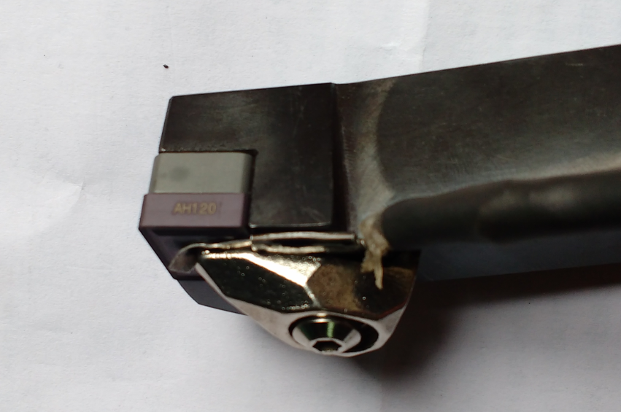

**4.4 PROFILE PROJECTOR**

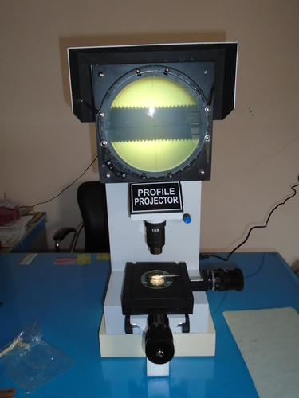

Specifications

Theory Stereo Microscope

Magnification 20X, 40X, 50X, 100X, 200X, 400X or 450X

Eyepieces 5X HY, 10X WF or (15X optional)

Supply Ability : 5000 Unit Per Month

**4.5 TALLY SURF**

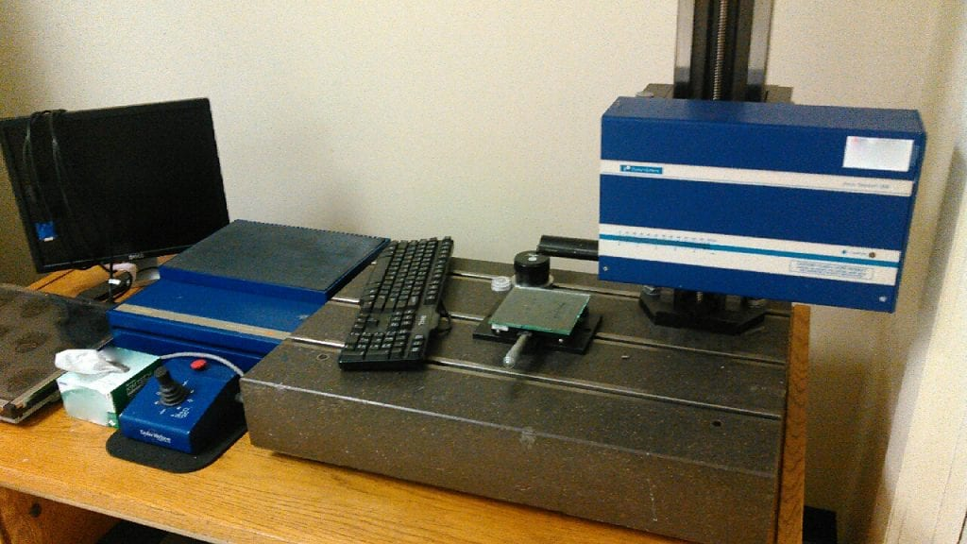

**4.6 WIRE EDM MACHINE** :-

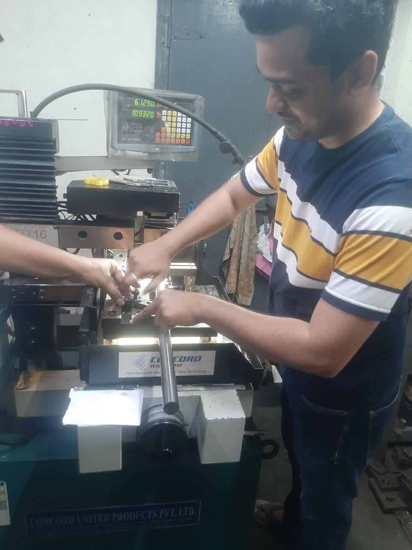

specification

Wire electrode diameter: in the range of 0.05-0.3 mm 4. Work-piece weight: 1500 kg or less 5. Taper angle: ± 25°/50 mm or more 6. Job admit: at least 275 mm or more 7.

**CHAPTER 5**

**Theory**

**5.1 Design of Experiments:**

Sir R.A.Fisher introduced a new statistical technique in 1920 called Design of Experiments (DOE). In the optimization technique, there are several parameters with their different levels, which can affect the performance of the product. Therefore, for that trial-and-error method, it is used to identify the best parameters that maintain the quality product. However, this method requires extensive experimental work and results in a great waste of time and money.

Thus, design of experiments appears to be an important tool for continuous and rapid improvements in quality. DOE is a powerful statistical technique for determining the optimal factor settings of a process and thereby achieving improved process performance, reduced process variability and improved manufacturability of products and processes [Antony J. and Antony F. It is a systematic route that may be followed so as to find solutions to industrial process problems with greater objectivity by means of experimental and statistical techniques.

In the present experimental, cutting speed (v), feed (f) and depth of cut (d) have been considered as cutting parameters, while the responses of interest are tool wear and surface roughness parameters (Ra and Rz). The identified factors and their associated levels.

**5.2 Taguchi Approach:**

Taguchi's method involves reducing the variation of a process through the robust design of experiments. The Taguchi method was developed by Dr. Genichi Taguchi of Japan who maintained this variation. Taguchi has developed an experimental design method to investigate how different parameters influence the Mean and variance of a process performance characteristic that defines how well the process is working. The experimental project proposed by Taguchi involves the use of orthogonal matrices to organize the parameters that influence the process and the levels at which they must vary. Instead of having to try all possible combinations, such as the factorial design, the Taguchi method checks the pairs of combinations.Taguchi methods have been widely used for product design and process optimization [Dean (1991)]. This is due to the advantages of the design of experiment using Taguchi’s technique, which includes simplification of experimental plan and feasibility of study of interaction between different parameters.

Taguchi method involves the stages of system design, parameters design, and tolerance design. System design involves the application of scientific and engineering knowledge required in manufacturing a product, parameter design is used to finding optimal process values for improving the quality characteristics, and tolerance design used for determining and analyzing tolerances in the optimal settings recommended by parameter design [Rao (2011)]. Analysis of variance (ANOVA) is then used to determine which process parameter is statistically significant and the contribution of each process parameter towards the output characteristic. With the main effect and ANOVA analyses, possible combination of optimum parameters can be predicted [Durairaj et al. (2013) and Raghuraman et al. (2013). The Taguchi method is a powerful troubleshooting technique to improve process performance, yield and productivity [Kamaruddin et al. (2004) and Unal and Dean (1991)]. Using the Taguchi analysis, the effect of different process parameters at different levels in different load cells is analyzed and optimal configurations of the various parameters have been obtained. This is a form of experiment design (DOE) with special application principles. Taguchi recommends that the experimental statistical design method can be used to help improve quality, especially when designing parameters and tolerances. The following are the different terms used in the Taguchi method.

**5.3 A.Steps in Taguchi Experimental Design:-**

Taguchi method is one of the most powerful designs of experiment to understand process characteristics and to investigate how experimental parameters affect final results (responses) based on statistical backgrounds. The steps required in Taguchi method are explained belo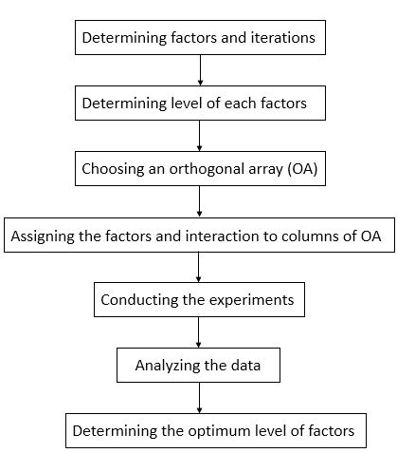w.

* 1. **Selection of the independent variables**

In the metal cutting process there are many parameters that influence the surface finish and useful life of the instrument. Therefore, it is a challenging task to select the appropriate cutting parameters to increase the useful life of the instrument with the desired surface finish. Therefore, before performing the experiment, it is important to select factors that influence the result that you can perform by doing research to find an optimal combination of cutting parameters. When arbitrating several publications related to the following parameters are considered critical, ie speed, advance, depth of cut (DOC).

In the present experimental study, cutting speed (v), feed (f) and depth of cut (d) have been considered as cutting parameters, while the responses of interest are cutting force (Fc) and surface roughness parameters (Ra and Rz).

* 1. **Deciding the number of levels.**

Once the independent variables are decided as indicated in the previous step, the number of levels for each variable is decided. The selection of the number of levels depends on how the performance parameter is affected due to the different level configurations. If the performance parameter is a linear function of the independent variable, the level adjustment number must be 2. However, if the independent variable is not linearly related, it could go to levels 3, 4 or higher depending on whether the relationship is quadratic, cubic or higher order. In the absence of the exact nature of the relationship between the independent variable and the performance parameter, 2 configuration levels can be chosen. After analyzing the experimental data, the three levels of each input parameter are selected.

To obtain the optimum value of input parameters of the Inconel 718 material is the main challenge for company. On this project we focused on finish dry hard turning Inconel 718 material with Carbide tool by employing combined techniques L9 orthogonal to determine the effect of cutting parameters (cutting speed, feed and depth of cut) on cutting force (Fc) and surface roughness (Ra, Rz). The results show that feed and cutting speed strongly influence surface roughness; whereas depth of cut is the principal significant factor affecting cutting force followed by feed. The prediction of optimal range of the input parameters. So perfect cut solution company gives the challenge to obtain the optimum cutting condition.

* 1. **Process Selection**

In this Research machining process parameter are taken as varying by keeping all other process parameter constant. Level of machining process parameters are selected by referring the national and international machining standards and also experiences in application are taken into consideration.

Experiments done by varying following parameters

a. Cutting speed

b. Feed

c. Depth of cut

**Selection of Process Parameters**

In DOE approach, minimum three levels of process parameters chosen because to reflect the true behavior of output parameters for study. The critical parameters and corresponding levels of each parameter, is shown in Table 3

|  |  |  |  |  |  |
| --- | --- | --- | --- | --- | --- |
| **Sr. No.** | **Parameters** | **Unit** | **Level 1** | **Level 2** | **Level 3** |
| 1 | Speed | m/min | 40 | 50 | 60 |
| 2 | Feed | mm/rev | 0.08 | 0.1 | 0.12 |
| 3 | DOC | mm | 0.8 | 1 | 1.2 |

Table 5.6.1: Selecting critical parameters and levels

* 1. **Selection of an orthogonal array**

Before selecting the orthogonal array, the minimum number of experiments to be conducted shall be fixed based on the total number of degrees of freedom present in the study. The minimum number of experiments that must be run to study the factors shall be more than the total degrees of freedom available. For current work are selecting (L9) orthogonal array, using three parameters and three levels for each, the number of experiments required can be drastically reduced to nine, which in classical combination method using full factorial experimentation would require 34 = 81 number of experiments to capture the influencing parameters.

The selection of a particular orthogonal array is based on the number of levels of various factors. Here, to conduct the experiments 3 factors with each having 3 levels were selected.

Now the Degree of Freedom (DOF) can be calculated by using Eq. 2 as,

Equation 2: Degrees of Freedom

DOF = 3(3 – 1) = 6

Where,

DOF = Degrees of freedom

Number of factors and L = Number of levels

The L9 array is shown in table 1

However, total DOF of the orthogonal array (OA) should be greater than or equal to the total DOF required for the experiment that means 9 > 6, Therefore L9 (34) orthogonal array is selected to assign various columns.

|  |  |  |  |
| --- | --- | --- | --- |
| **Exp. No.** | **Speed (m/min)** | **Feed (mm/rev)** | **Depth of Cut (mm)** |
| 1 | 40 | 0.08 | 0.8 |
| 2 | 40 | 0.10 | 1.0 |
| 3 | 40 | 0.12 | 1.2 |
| 4 | 50 | 0.08 | 1.0 |
| 5 | 50 | 0.10 | 1.2 |
| 6 | 50 | 0.12 | 0.8 |
| 7 | 60 | 0.08 | 1.2 |
| 8 | 60 | 0.10 | 0.8 |
| 9 | 60 | 0.12 | 1.0 |

**Experimental layout is shown in Table 5.7.1.**

* 1. **Assigning the independent variables to column**

The order in which the independent variables are assigned to the vertical column is an essential. In case of mixed level variables and interaction between variables, the variables are to be assigned at right columns as stipulated by the orthogonal array. Finally, before conducting the experiment, the actual level values of each design variable shall be decided. It shall be noted that the significance and the percent contribution of the independent variables changes depending on the level values assigned. It is the designer’s responsibility to set proper level values.

|  |  |  |  |
| --- | --- | --- | --- |
| **Experiment No.** | **Independent Variables** | | |
| **Variable 1** | **Variable 2** | **Variable 3** |
| 1 | 1 | 1 | 1 |
| 2 | 1 | 2 | 2 |
| 3 | 1 | 3 | 3 |
| 4 | 2 | 1 | 2 |
| 5 | 2 | 2 | 3 |
| 6 | 2 | 3 | 1 |
| 7 | 3 | 1 | 3 |
| 8 | 3 | 2 | 1 |
| 9 | 3 | 3 | 2 |

**Table 5.7.2: DOE with L9 Array**

* 1. **Conducting the experiment**

Once the orthogonal matrix is ​​selected, experiments are performed based on combinations of levels. All experiments must be performed. The performance parameter in the studio is recorded for each experiment to perform sensitivity analysis.

Taguchi method is used in the industry to decrease the product development period for the design and production which also decrease the costs and increase the profit of the company. Taguchi method also allows controlling the variations caused by the uncontrollable factors which are not taken into consideration at conventional design of experiment. Taguchi converts the objective function values to signal-to-noise (S/N) ratio for measure the performance characteristics of the levels of control factors against these factors. S/N ratio is defined as the desired **signal ratio** for the undesired random noise value and shows the quality characteristics of the experimental data . There are three different functions used which are known as the objective function and also defined as S/N ratio: **‘‘the-larger-the-better’’, ‘‘the-smaller-the-better’’ and ‘‘the-nominal-the-best’’.** Besides, ANOVA is used to determine the statistical significance of the cutting parameters. The optimum combination of the cutting parameters is determined by the help of ANOVA and S/N ratios. Lastly, confirmation experiments are done using the optimum 914 M. Günay, E. Yücel / Measurement 46 (2013) 913–919 machining parameters which were found by Taguchi **optimization** method and thereby validation of the optimization is tested [14].

**5.8 EXPERIMENTAL WORK**

In this section we will discuss every aspect about experimental work carried out as a part of this study project. We have discussed this already in previous chapters, temperatures generated during any machining process affects overall machining process as it affects properties of both tool and work piece. Any change in material properties during machining can adversely affect the overall process and if this change is not predicted well in time then it may lead to serious failure and can affect the outcome of the process very badly. Again, when we are talking about a hard to machine and very expensive alloy like Nikel things get more serious. Because of its hard to machine nature, lot of heat is generated during turning operation and the alloy itself being less efficient in carrying away that heat adds to problem further.

Whenever we want to study and establish some parameter, like temperature, experimentation carries lot of weightage. Further if we manage to simulate the same process then scalability of the temperature prediction increases exponentially. Also, experimentation aids in validating and correcting, if needed, the simulation parameters so as to make it as accurate as possible. Documenting each and every parameter becomes important when we are doing it for study project, because then it aids in controlling the overall process as per our need and feedback obtained from previous runs of experiment. Here in our case some important parameters are:

* Selection of work piece material based on properties
* Selection Specimen
* Selection of Tool Insert
* Selection of Tool holder
* Experimental apparatus
* Process parameter.

**5.9 Analyzing the data**

**5.9.1 Surface roughness :**

Since each experiment is the combination of different factor levels, it is essential to segregate the individual effect of independent variables. The S/N ratio is treated as a response of the experiment, which is a measure of the variation within a trial when noise factors are present. A standard ANOVA can be conducted on S/N ratio which will identify the significant parameters.

Since each experiment is the combination of different factor levels, it is essential to segregate the individual effect of independent variables. The S/N ratio is treated as a response of the experiment, which is a measure of the variation within a trial when noise factors are present. A standard ANOVA can be conducted on S/N ratio which will identify the significant parameters

the main effects for surface roughness parameters, Ra and Rz are plotted. Increasing of feed rate and decreasing of cutting speed lead to increase surface roughness. The main effect plots indicate that, surface roughness leads to increase, significantly with increasing in feed. This is predicted as well as known that, the theoretical surface roughness is principally dependent upon the feed rate, for a certain nose radius of tool insert (Shaw, 2005). The other reason is, feed generates helicoids and furrows the result of plowing action of tool shape and helicoids movement tool-workpiece.

**5.9.2 Tool wear :**

At the early stage of cutting, initial breakdown in cutting edge with the edge rounding is observed with only a flank wear which increases rapidly. Then the flank wear becomes stable and stay constant, while a crater wear appears on the rake face which is typical of abrasive wear. Finally, the tool-wear becomes uncontrollable and it leads to a tool tip failure . Therefore, it is important to take corrective measures on time before the breakage to enable large damages on the surface of the workpiece. For each test, the progression of the tool-wear rate was monitored.



* 1. **Analysis of Variance (ANOVA**)

This method was developed by Professor R. A. fisher. ANOVA is an extremely useful technique which is used when multiple sample cases are involved. The basic principle of ANOVA is to test the means of the population by examining the amount of variation within each of this sample relative to the amount of relation between the samples. In terms of variation within the given population, it is assumed that the value of (yij) differ from the mean of this population only because of random effects that is there are influences on (yij) which are unexplainable, where as in examining difference between the mean of the jth population and the grand mean is attributable to what is called air treatment effect. Thus it has to make to estimate of population variance, in other words, one based on between sample variance and the other based on within sample variance. Then these two instruments of population variance are compared with F-test.

**F = Estimate of population variance based between sample variance  
 Estimate of population variance based on within sample variance**

This value of F ratio be compared to the F-limit for given degree of freedom. If the F

value worked out is equal or exceed the F-limit table value, it may conclude that there

are significant differences between the sample means.

5.10.1 **Selecting optimum factor levels**

A primary goal in conducting a matrix experiments is to optimize the product or process design, to determine the best or the optimum level for each factor. The optimum level for a factor is the level that gives the highest value **of S/N ratio** in the experimental region. The estimated main effects can be used for this purpose provided the variation of S/N ratio as a function of the factor level follows the additive model.

**5.11 Signal to noise ratio**

In Taguchi method, the term “signal” represent the desirable value for the output characteristics and “noise” represents the undesirable value of output characteristics. The objective to determine signal to noise ratio is to develop the processes that are insensitive to noise. A process parameter setting with the highest signal to noise ratio always yields optimum quality with minimum variance. In general signal to noise ratio signifies the ratio of mean to the standard deviation.

The Taguchi method includes the noise factors in the experiment for the purpose of identifying control factors settings which are robust against noise, i.e. those settings of the design factors which produce the smallest variation in the response across the different levels of the noise factors. Some combinations of control factor settings may yield output that is affected by the noise factors, thus causing the response to vary around its mean, while for other combinations; the output is insensitive to the changes in the noise factors. Similarly, the quality characteristic might exhibit more variability at, say, the low setting of a certain control factor than it does at the high setting. For other control factor, the variation in the quality characteristic might be nearly constant across the levels of those control factors, while the average quality characteristic might or might not change across the levels of these control factors. Some factors may arise that impact the mean but not the variations such adjustment factors may be used to move a process onto or towards its target value, without affecting the variation around the target. In a two-step adjustment process, the variation is minimized by the appropriate setting of the factors that affect the variation, and then the output is centered at the target value by the appropriate settings of the factors that only influence the mean. Factors which appear to have little or no impact on either the mean or the variation are typically set to the level representing the lowest cost. In order to achieve its goals, the Taguchi method analyses not the measured response but rather some transformation of that response, depending on the situation. As Taguchi method aims to minimize the expected loss, but it does not base the analysis on this quantity directly. A signal to noise ratio is calculated, the choice of the particular signal to noise ratio depends on the desired outcome of the response as below.

**CHAPTER 6**

**RESULTS**

* 1. **Effect of Process Parameter on Surface Roughness.**

Following table show feed, speed and depth of cut applied during turning process and recorded surface roughness as an outcome of process.

|  |  |  |
| --- | --- | --- |
| Sr. No. | Specimen | Cutting Parameters |
| 1 |  | Speed: 40  Feed: 0.08  DOC: 0.8  Surface roughness: 078 |
| 2 |  | Speed: 40  Feed: 0.1  DOC: 1  Surface roughness:0.81 |
| 3 |  | Speed: 40  Feed: 0.12  DOC: 1.2  Surface roughness:0.89 |
| 4 |  | Speed: 50  Feed: 0.08  DOC: 1  Surface roughness:0.68 |
| 5 |  | Speed: 50  Feed: 0.1  DOC: 1.2  Surface roughness:0.71 |
| 6 |  | Speed: 50  Feed: 0.12  DOC: 0.8  Surface roughness:0.75 |
| 7 |  | Speed: 60  Feed: 0.08  DOC: 1.2  Surface roughness:0.60 |
| 8 |  | Speed: 60  Feed: 0.1  DOC: 0.8  Surface roughness:0.63 |
| 9 |  | Speed: 60  Feed: 0.12  DOC: 1  Surface roughness:0.65 |

Average surface roughness (Ra) occurred during machining of the Ni-Hard materials was measured after the experiments performed according to the L9 orthogonal array. The experimental results and S/N ratios calculated according to Taguchi’s **‘‘the-smaller-the-better’’ quality characteristic.**

|  |  |  |  |
| --- | --- | --- | --- |
| **Speed** | **Feed** | **DoC** | **Surface Roughness (µm)** |
| 40 | 0.08 | 0.8 | 0.78 |
| 40 | 0.10 | 1.0 | 0.81 |
| 40 | 0.12 | 1.2 | 0.89 |
| 50 | 0.08 | 1.0 | 0.68 |
| 50 | 0.10 | 1.2 | 0.71 |
| 50 | 0.12 | 0.8 | 0.75 |
| 60 | 0.08 | 1.2 | 0.60 |
| 60 | 0.10 | 0.8 | 0.63 |
| 60 | 0.12 | 1.0 | 0.65 |

**Table 6.1.1 For Surface Roughness**

**6.2 Effect of Process Parameter on Tool Wear .**

Machining of superalloy Inconel 718 would have established some issues like, inability of the tool materials to sustain for a longer duration due to the work hardening effect and very high cutting forces causes metallurgical damage on the work pieces. This research paper focuses on the tool life issues of different tool materials associated with the turning of Inconel 718 under different cutting conditions. Further, it is significant to identify the parameters that cause the machining characteristics, in particular the flank wear and to understand the relationship they have with the different controllable parameters. Turning experiments on Inconel – 718 were investigated under different cutting conditions using three controllable parameters namely feed rate, cutting speed and depth of cut.

Average surface roughness (Ra) occurred during machining of the Ni-Hard materials was measured after the experiments performed according to the L9 orthogonal array. The experimental results and S/N ratios calculated according to Taguchi’s **‘‘the-smaller-the-better’’ quality characteristic.**

|  |  |  |  |
| --- | --- | --- | --- |
| **Speed** | **Feed** | **DoC** | **Tool Wear (µm)** |
| 40 | 0.08 | 0.8 | 85 |
| 40 | 0.10 | 1.0 | 95 |
| 40 | 0.12 | 1.2 | 100 |
| 50 | 0.08 | 1.0 | 105 |
| 50 | 0.10 | 1.2 | 125 |
| 50 | 0.12 | 0.8 | 115 |
| 60 | 0.08 | 1.2 | 120 |
| 60 | 0.10 | 0.8 | 115 |
| 60 | 0.12 | 1.0 | 130 |

**Table 6.1.2 for Tool wear**

**CHAPTER 7**

**Graphical representation for the tool wear and surface roughness .**

**7.1 Surface Roughness:**



Graphs of average surface roughness obtained in hard turning of Inconel 718 .These graphs have been constructed to illustrated the variations of Ra depending on depth of cut (a)-cutting speed (V) and feed rate (f)-cutting speed (V). Surface roughness values are close to each other, which have obtained in machining Carbide cutting tools as 40m/min cutting speed of Ni-Hard with 50 HRC**. The highest Ra value has obtained as 0.89 in hard turning with Carbide of this material at 1.2mm depth of cut. When the Ra results for 60 m/min cutting speed were evaluated, Ra values obtained with carbide decreased parallel to deceased in the depth** of while the variation of Ra values for carbide cutting tool showed an irregular tendency.



**7.2 Tool Wear**

A decreasing workpiece hardness will induce a cutting speed increase to maintain the same tool-life and vice versa; •

Increase the cutting speed will reduce the tool-life .

**reducing the feed rate and the depth of cut we get the optimum value of tool wear**





**CHAPTER 8**

**Conclusion**

**I**n this project, the statistical methods of signal-to-noise (S/N) ratio and the analysis of variance are applied to evaluate the effects of cutting parameters on average surface roughness and to find the optimal variable levels for the better surface roughness occurred in hard turning of Inconel 718 (40HRC).

smallest Ra values is being calculating during machining of Inconel 718 with 65 HRC with Carbide cutting tool . Average surface roughness (Ra) occurred during machining of the Ni-Hard materials was measured after the experiments performed according to the L18 orthogonal array. The experimental results and S/N ratios calculated according **to Taguchi's "the smaller-the- better" quality,**

**8.1 Optimum value of surface roughness obtained in experimentation.**

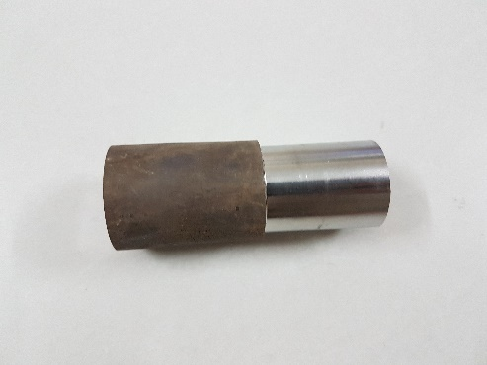

|  |  |  |  |
| --- | --- | --- | --- |
| Speed | Feed | Depth of cut | Optimum surface value (Ra) |
| 60 | 0.08 | 1.2 | 0.60 |

**Table 8.1.1 For Optimum surface value**

**The smallest Ra values occurred during machining of Inconel 718 with 40HRC hardness are obtained as 0.60 mm with Carbide cutting tool.**

**8.2 Optimum value of tool wear obtained in experimentation**

|  |  |  |  |
| --- | --- | --- | --- |
| Speed | Feed | Depth of cut (mm) | Tool wear (um) |
| 40 | 0.08 | 0.8 | 85 |

**Table 8.2.1 for optimum Tool Wear**

The main wear mechanism of the Carbide tools is abrasion by hard alloy carbide particle contained in the workpiece. Moreover, abrasion of the cutting tool depends on the nature of the carbides, their size, their repartition, etc. The different work materials at the same hardness value cannot be assumed equal according to tool-wear viewpoint.

**We getting the optimum value for tool wear is the 85um for the feed rate of 0.08mm and the cutting speed is 40**

**CHAPTER 9**

**Cost Estimation**

|  |  |  |
| --- | --- | --- |
| **SR. No** | **Equipment or Material** | **Price RS** |
| **1.** | **Round bar of Inconel 718** | **9830/-** |
| **2.** | **Carbide insert** | **300/-** |
| **3.** | **Material composition report** | **1000/-** |
| **4.** | **Material cutting cost** | **1500/-** |
| **5.** | **Machine operating cost** | **2000/-** |

**CHAPTER 10**

**References**

* S.M. Athavale, J.S. Strenkowski, Finite element modeling of machining: from proof-of- concept to engineering applications, Mach. Sci. Technol. 2 (2) (1998) 317–342.
* F. Klocke, T. Beck, S. Hoppe, T. Krieg, et al., Examples of FEM application in manufacturing technology, J. Mater. Proc. Technol. 120 (2002) 450–457.
* W. Zhang, O.W. Dillon, I.S. Jawahir, A finite element analysis of 2- D machining with a grooved ool, Trans. NAMRI/SME 29 (2001) 327–334.
* M.R. Movahhedy, M.S. Gadala, Y. Altintas, Simulation of chip formation in orthogonal metal cutting process: an ALE finite element approach, Mach. Sci. Technol. 4 (1) (2000) 15–42.
* E. Usui, T. Shirakashi, Mechanics of Machining-from Descriptive to Predictive Theory On the Art of Cutting Metals-75 Years Later, vol. 7, ASME PED, New York, 1982. Pp.13–55.
* K. Iwata, K. Osakada, Y. Teresaka, Process modeling of orthogonal cutting by a rigid-plastic finite element method, J. Eng. Mat. Technol. 106 (1984) 132–138.
* C.H. Che-Harona, A. Jawaid, “The effect of machining on surface integrity of titanium alloy Ti–6% Al–4% V”, Journal of Materials Processing Technology 166 (2005) 188–192.
* M. Cotterell, G. Byrne, “Dynamics of chip formation during orthogonal cutting of titanium alloy Ti–6Al–4V”, CIRP Annals – Manufacturing Technology 57 (2008) 93–96.
* S. Sun, M. Brandt, M.S. Dargusch, “Machining Ti–6Al–4V alloy with cryogenic compressed air cooling”, International Journal of Machine Tools & Manufacture 50 (2010) 933–942.
* Suresh Palanisamy, Stuart D. McDonald, Matthew S. Dargusch, “Effects of coolant pressure on chip formation while turning Ti6Al4V alloy”,International Journal of Machine Tools & Manufacture 49 (2009) 739–743.
* S. Sun, M.Brandt, M.S.Dargusch, “Characteristics of cutting forces and chip formation in machining of titanium alloys”, International Journal of Machine Tools & Manufacture 49 (2009) 561–568.
* T.D. Marusich, M. Ortiz, Modelling and simulation of high-speed machining, Int. J. Numer. Methods Eng. 38 (1995) 3675–3694.
* Y.-Ch Yen, A. Jain, T. Altan, A finite element analysis of orthogonal machining using different tool edge geometries, J. Mater. Proc.Technol. 146 (2004) 72–81.
* E.G. Loewen, M.C. Shaw, On the analysis of cutting tool temperatures, Trans. ASME 76 (1954) 217–231.
* G. Sutter, G. List, “Very high speed cutting of Ti–6Al–4V titanium alloy – change in morphology and mechanism of chip formation”, International Journal of Machine Tools & Manufacture 66 (2013) 37–43.